Anaphora Resolution

Anaphora Resolution is a term which refers to Pronoun Resolution. This indicates the difficulty in figuring out which pronoun refers to which noun in the sentence.

Example:
The Empress hasn't arrived yet but she should be here any minute.
She --> Anaphor
The Empress (NP) --> Antecedent
Empress (N) is NOT the antecedent !
Coreferent --> Both The Empress and she refer to the same REAL WORLD ENTITY.

Catafora refers to when the “anaphor” precedes the “antecedent”.
Example :
Because she was going to the post office, Julie was asked to post a small parcel.

Anaphora Resolution(AR) is the process of determining the antecedent of an anaphor.
Anaphor – The reference that points to the previous item
Antecedent –The entity to which anaphor refers
It is needed to derive the “Correct Interpretation” of a text.
Is a complicated problem in NLP !

Applications of Anaphora Resolution :

- Natural Language Interfaces
- Machine Translation
- Automatic Abstracting
- Information Extraction

Coreferential Chain :

When the anaphor and more than one of the preceding (or following) entities (usually noun phrases) have the same referent and are therefore pairwise coreferential, they form a coreferential chain.
Example :
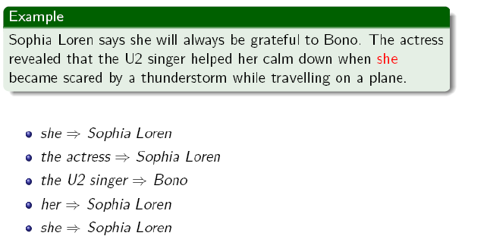

Anaphora Resolution vs Coreference Resolution

Anaphora Resolution :
System has to determine antecedents of anaphors.

Anaphora vs Coreference Resolution :

Anaphora Resolution
System has to determine antecedents of anaphors.

Coreference Resolution
System has to identify all coreference CHAINS.
The task of AR is considered successful, if any of the preceding entities in the coreferential chain is identified as an antecedent.

Types of Anaphora :

- Pronominal anaphora
The most widespread type of anaphora.
Not all pronouns in English are anaphoric.
Example :
It is raining.
'It' is non-anaphoric.

- Definite noun phrase anaphora
When the antecedent is referred by a definite noun phrase representing either same concept (repetition) or semantically close concepts (e.g. synonyms, superordinates).
Example :
Computational Linguists from many different countries attended the tutorial. The participants found it hard to cope with the speed of the presentation.

- One-anaphora
One-anaphora is the case when the anaphoric expression is realized by a "one" noun phrase.
Example:
If you cannot attend a tutorial in the morning, you can go for an afternoon one.
Some are easier than others.
The red ones went in the side pocket.

Intrasentential vs Intersentential Anaphors :

Intrasentential anaphors :
Referring to an antecedent which is in the same sentence as the anaphor.
Intersentential anaphors :
Referring to an antecedent which is in a different sentence from that of the anaphor.

Process of Anaphora Resolution :

- Identifying anaphors which have noun phrases, verb phrases, clauses, sentences or even paragraphs/discourse segments as antecedents.
- Most of the AR systems deal with identifying anaphors which have noun phrases as their antecedents.
- All noun phrases (NPs) preceding an anaphor are initially regarded as potential candidates for antecedents.
- Most approaches look for NPs in the current and preceding sentence. Antecedents which are 17 sentences away from the anaphor have already been reported !

Anaphora Resolution Tools :

- GUITAR
http://cswww.essex.ac.uk/Research/nle/GuiTAR/gtarNew.html
- BART
http://www.bart-coref.org/
- MARS
http://clg.wlv.ac.uk/demos/MARS/index.php
- Java-RAP (pronouns)
http://aye.comp.nus.edu.sg/~qiu/NLPTools/JavaRAP.html
- OPEN NLP
http://opennlp.sourceforge.net
- CherryPicker: A Coreference Resolution Tool
http://www.hlt.utdallas.edu/~altaf/cherrypicker.html
- Reconcile - Coreference Resolution Engine
http://www.cs.utah.edu/nlp/reconcile/

The best to use is BART (Beautiful Anaphora Resolution Toolkit). It works.
The link : http://www.bart-coref.org

Majority of Anaphora resolution systems do not operate in fully automatic mode.
Fully automatic AR is more difficult than previously thought.

